Design:

My home page with profile picture and short paragraph about me

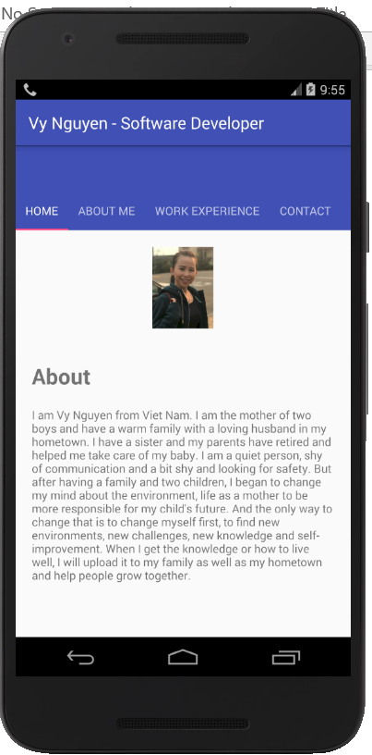

Tab about me will show my soft skill and programming skill

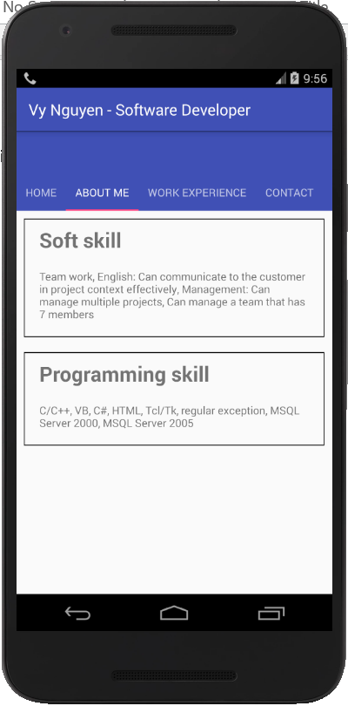

Tab work experience will show about my working history

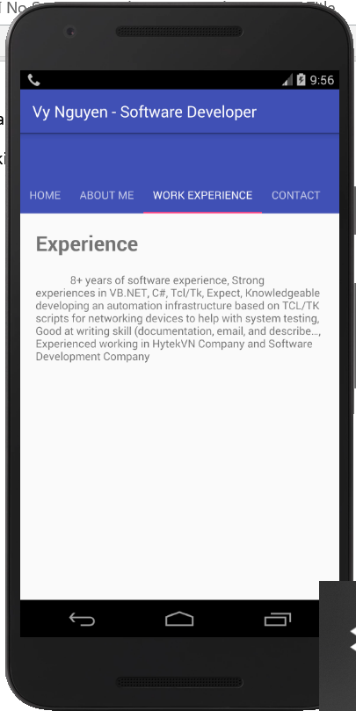

Tab contact will show my contact information

